**Docufen’s Testing Document**

|  |  |  |
| --- | --- | --- |
| **Signatures** | **Pre-Approval** | **Post-Approval** |
| **PREPARED BY:**  Grady Archie  **Validation Engineer** |  |  |
| **REVIEWED BY:**  Julia Smith  **External Consultant** |  |  |
| **APPROVED BY:**  Julia Smith  **Quality Manager** |  |  |
| **Sign / Name:** | Sign:____________  Name: ____________ | Name:____________  Name: ____________ |

Signature: ____________________________

Date: ________________________

Signature:

Date:

|  |  |  |
| --- | --- | --- |
| Checkbox | ☐ | ☐ |
| Text | weight (kg): _________________ |  |
| Attachment image |  |  |
| Attachment video |  |  |
| Attachment PDF |  |  |

Signature: ____________________________ Date: ________________________

Signature: ____________________________ Date: ________________________

1. OQ Test Script

Test Objective: Fringilla phasellus faucibus sceleriue eleifend donec pretium vulputate.

Acceptance Criteria: Et malesuada fames ac turpis egestas maecenas pharetra.

Test Procedure: Odio eu feugiat tium nibh ipsum consequat nisl vel pretium.

|  |  |  |  |
| --- | --- | --- | --- |
| **Results** | | | |
| **Test Description** | **Result** | **Acceptance Criteria Met?** | **Initials / Date** |
| Sterilisation Setpoint temperature = 121oC |  | Yes ☐  No ☐ |  |
| Attachment: |  | | |
| Placeholder: | Enter the weight (kg): _________________  Enter the weight (kg): _________________  Enter the weight (kg): _________________ | | |
| **Comments:** |  | | |

Comments:

Checkbox: ☐

Checkbox: ☐

Checkbox: ☐

Comments: _____________

|  |  |
| --- | --- |
| **Results Summary**[1] | |
| Have all the acceptance criteria been met?  Yes = **PASS** | No = **FAIL** | Yes = PASS ☐  No = FAIL ☐ |
| **Performed by:**  (Sign / Date) |  |

1. 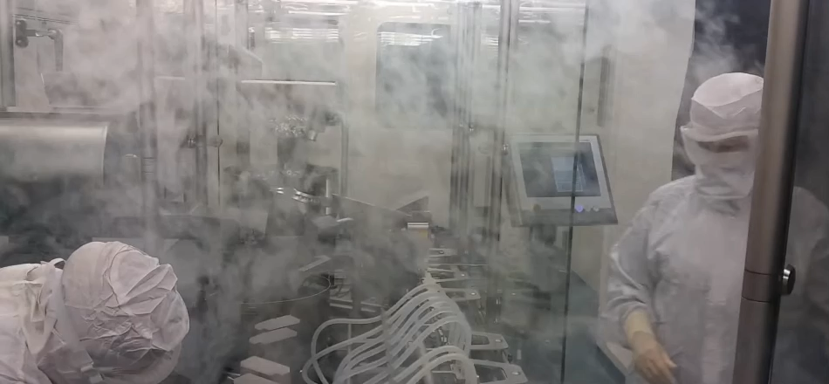Attachment Log

|  |  |  |  |
| --- | --- | --- | --- |
| **No.** | **Description** | **No. of Pages** | **Initials / Date** |
| 1 |  |  |  |
| 2 |  |  |  |
| 3 |  |  |  |
| 4 |  |  |  |
| 5 |  |  |  |



1. Footer example: Enter the results summary in this section.